**9 PEAKS CHALLENGE ITINERARY**

**15th to 19th May 2025**

**(All timings approximate and subject to change)**

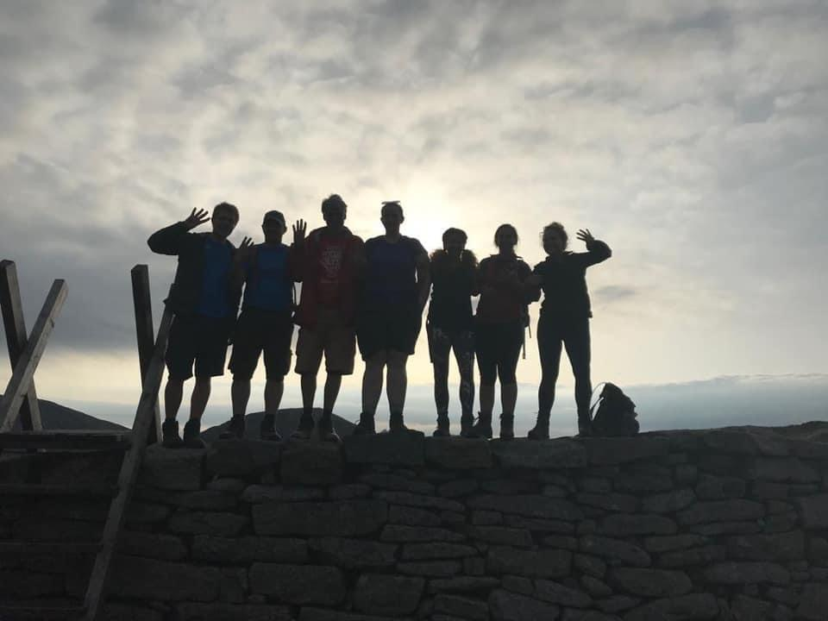

**Day One – Thursday, 15th May 2025**

1pm - Pick up the team from Birmingham International Station

3pm – Stop for mountain snacks

5.30pm – Arrive at hotel for food and refreshment

7pm – Meal / Team Briefing

**Day Two – Friday, 16th May 2025**

6am – Meet for breakfast

6.30am - Depart for Snowdon

6.50am - Safety Briefing

7.00m - Start Snowdon climb

9am – Summit Snowdon One of Nine in the bag!!

Walk directly from Snowdon summit to Crib y Ddysgl

9.30am – Summit Crib y Ddysgl – Two in the bag already!

11am – Arrive back at car park

11.15am - Depart

12.15pm – Arrive Carnedd Llewelyn – Safety Briefing

2.15pm – Summit Carnedd Llewelyn – THREE DOWN!!

4.15pm – Arrive back at Car Park

4.30pm – Depart

6.15pm – Toilet / Rest Stop

8.30pm – Arrive Scafell Pike Safety Briefing

8.45pm – Climb Scafell Pike

10.45pm Summit Scafell Pike - FOUR DONE AND DUSTED!!

Depart Scafell Pike hike to Scafell.

11.30pm – Summit Scafell – FIVE IN THE BAG – Got to be feeling it now surely??

11.45pm - Depart Scafell

**Day Three – Saturday, 17th May 2025**

2am - Back at Car Park

2.20am - Depart

3.45am - Arrive Helvellyn safety Briefing

4.15am - Start Helvellyyn

6.45am - Summit Helvellyn NUMBER SIX – How many of the team are still going??!!

8.30am - Back at Van

9am – Depart for Scotland!!

11.30am - Rest Stop

2pm – Arrive Ben Nevis – Safety Briefing

4.45pm - Summit Ben Nevis - Number 7 - Only the Toughest of the tough will still be going!!

7.15pm – Back at Base

7.30pm - Depart

9.30pm - Arrive at Ben Macdui – Safety Briefing

9.45pm - Start Ben Macdui

**Day Four – Sunday, 18th May 2025**

12.30am - Summit Ben Macdui – Number Eight – Anyone Left??

3.00am - Back at base

3.15am - Depart

4.30am - Arrive Braeriach – Safety Briefing

4.45am - Start climb

9am – Summit Braeriach – Celebrate the greatest achievement of all time!

12.30pm - Back at Vans. Cry!

2pm - Check into hotel in Aviemore. Sleep. Party. Whatever takes your fancy.

6pm – Meal in the bar to celebrate.

**Day Five – Monday, 19th May 2025**

8am - Breakfast

9am - Depart

9.10am – Drop off Aviemore Station

(Earlier drop off available for direct train to London if required)

12pm – Drop off Glasgow Airport Travelodge (short walk to terminal)

**COSTS £995PP**

**INCLUSIONS**

Comfortable 8 Seater MPV vehicle throughout Challenge

Qualified Mountain Leaders throughout

Hotels Day One and Four

Experienced event leader throughout

Kit and Training Guide

A fantastic and unforgettable experience

**NOT INCLUDED**

Drinks and meals on the challenge

Return transport from Scotland

Transport to Birmingham International (start point)